Spanning Tree Protocol (STP)

1. Redundancy is good
   1. Enables users to access network resources, despite path disruption.
      1. Improves reliability
      2. Improves availability
   2. In technology, 2 is 1 and 1 is none. Single connection mean single point of failure
      1. Creating redundant links is very simple and is advisable

Example for multiple ways to connect from one device to another:

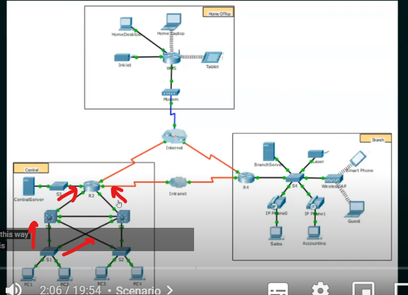

Broadcast storm

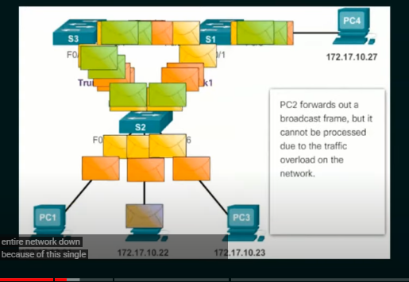

1. PC1 forwards out a broadcast that gets caught in a layer 2 loop.
2. Pc4 forwards out a new broadcast that also gets caught in the layer 2 loop
3. Pc2 forwards out a broadcast frame, but it canno proceed due to the traffic overload on the network.

STP prevents loops

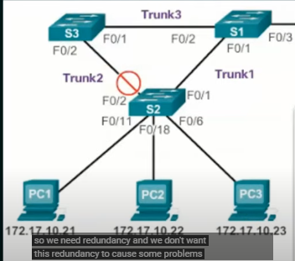

1. Original STP (802.1D) was created to prevent loops
2. Switches send probes into the netwrok to discover loops
3. These probes are called BPDU
4. BPDU = Bridge Protocol Data unit
5. BPDU will have specific information about the switch
6. Switch multicasts BPDU probes (every 2 seconds) and if it receives its own BPDU back, it means there is a loop in the network
7. Also the BPDU probes hep to elect the root bridge
8. All switches will find the best way to reach the root bridge and the redundant links will be blocked (port cost)

Election - Root bridge

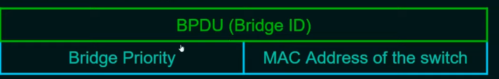

1. The root bridge will have the lowest bridge id
2. If tie, the bridge with the lowest MAC address will be the root bridge

Port Roles

1. Root port (Used to reach the root bridge)
2. Designated port (Forwarding port; One per link)
3. Blocking(Non designated port (loops)

Spanning Tree protocol

1. STP ensures that there is only one logical path between all destinations on the network by intentionally blocking redundant paths that could cause a loop
2. A port is considered blocked when user data is prevented from entering or leaving that port. This does not include bridge protocol data unit (BPDU) frames that are used by STP to prevent loops
3. The physical paths still exist to provide redundancy, but these paths are disabled to prevent the loops from occuring
4. If the path is ever needed to compensate for a network cable or switch failure, STP recalculates the path and unblocks the necessary ports to allow the redundant path to become active.

Homework

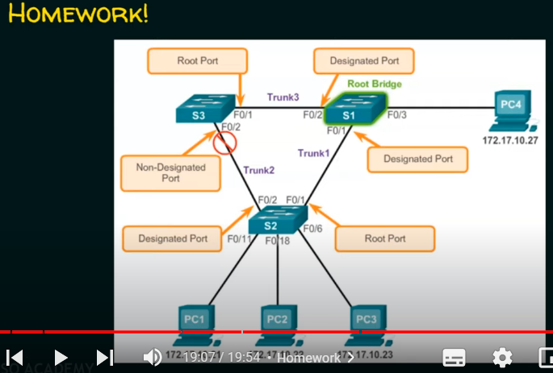

Answer from the comments: the F2 of the SW2 should be a non designated port